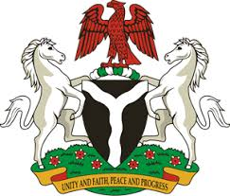
Please check against delivery

HUMAN RIGHTS COUNCIL
34TH SESSION OF THE WORKING GROUP OF THE UPR
REVIEW OF SLOVENIA
12TH NOVEMBER, 2019
STATEMENT BY NIGERIA
Madam Vice President,
Nigeria welcomes the delegation of the Republic of Slovenia to the presentation of its Third Cycle UPR National Report. We commend the Government of Slovenia for its cooperation with human rights mechanisms, and its efforts in implementing the previous recommendations.
2. We applaud the Government of Slovenia for its commitment to the promotion and protection of human rights and fundamental freedoms. Nigeria notes with appreciation, efforts by the Government of Slovenia to combat human trafficking and to ensure the protection of the rights of its victims. We also commend the Government’s policy on migration, and the protection of the rights of migrants.
3. In the spirit of constructive dialogue, Nigeria wishes to make the following recommendations to Slovenia:
- Sustain efforts in combatting hate speech and other hate crimes; and
- Continue efforts in combating human trafficking and upholding the rights of victims of human trafficking, as well as the rights of migrants.
4. In conclusion, we wish Slovenia a very successful review process.
I thank you Madam Vice President.
******

