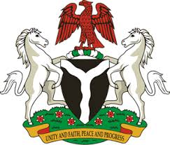
Please check against delivery
HUMAN RIGHTS COUNCIL
34TH SESSION OF THE WORKING GROUP OF THE UPR
REVIEW OF MADAGASCAR
11TH NOVEMBER, 2019
STATEMENT BY NIGERIA
Mr Vice President,
Nigeria warmly welcomes the delegation of the Republic of Madagascar to the presentation of the country’s UPR National Report for the Third Cycle, and thank them for the update provided today. We commend the Government of Madagascar for its continued cooperation with human rights mechanisms and its efforts in implementing the recommendations it accepted during the previous review.
2. We applaud the Government of Madagascar for ratifying a number of international instruments, as well as the efforts to strengthen the country’s legal and institutional frameworks for the promotion and protection of human rights. The Government’s efforts in combatting corruption, and its policy on poverty alleviation are commendable.
3. In the spirit of constructive dialogue, Nigeria wishes to recommend the following for the consideration of Madagascar:
- Not to relent in its poverty alleviation efforts, with a view to improving the general well-being of its people; and
- To continue to mobilise resources and seek necessary international support to enhance its capacity for the promotion and protection of human rights.
4. In conclusion, we wish Madagascar a very successful review process.
I thank you Mr Vice President.
******

