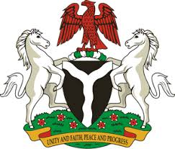
Please check against delivery
HUMAN RIGHTS COUNCIL
34TH SESSION OF THE WORKING GROUP OF THE UPR
REVIEW OF KAZAKHSTAN
7TH NOVEMBER, 2019
STATEMENT BY NIGERIA
Madam Vice President,
Nigeria welcomes the delegation of the Republic of Kazakhstan to the presentation of its National Report for the Third Cycle UPR. We commend the Government of Kazakhstan for its cooperation with UPR mechanisms and its efforts in implementing the previous recommendations.
2. We note with encouragement, the measures adopted by the Government of Kazakhstan in combatting the scourge of human trafficking, as well as to ensure the protection of the rights of its victims. The Government’s efforts in strengthening the rule of law through the reform of the country’s judicial system to enhance the administration of justice are also commendable.
3. In the spirit of constructive dialogue, Nigeria wishes to recommend the following to Kazakhstan:
- To scale up its efforts in combatting human trafficking, and upholding the rights of its victims; and
- To continue to develop and strengthen the judicial system in order to improve the quality of judicial decisions.
4. Finally, we wish Kazakhstan a very successful review process.
I thank you Madam Vice President.
******

