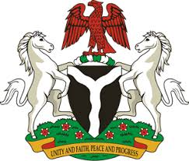
Please check against delivery

HUMAN RIGHTS COUNCIL
34TH SESSION OF THE WORKING GROUP OF THE UPR
REVIEW OF ITALY
4TH NOVEMBER, 2019
STATEMENT BY NIGERIA
Mr President,
Nigeria welcomes the delegation of Italy to the presentation of the country’s Third Cycle UPR National Report. We commend the Government of Italy for its cooperation with human rights mechanisms, and its efforts in implementing the previous recommendations.
2. We note with encouragement, Italy’s adoption of the first National Action Plan against Trafficking and Serious Exploitation of Human Beings, 2016 – 2018. We also commend the Government for its efforts in upholding the rights of migrants, as well as victims of human trafficking.
3. In the spirit of constructive dialogue, Nigeria wishes to make the following recommendations for the consideration of Italy:
- Not to relent in its efforts to ensure the protection of the rights of all migrants, particularly women and children; and
- To continue with its efforts in combating human trafficking and upholding the rights of its victims.
4. In conclusion, we wish Italy every success in its review process.
I thank you Mr President.
******

