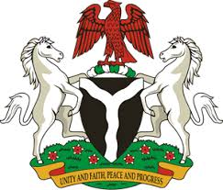
Please check against delivery

HUMAN RIGHTS COUNCIL
34TH SESSION OF THE WORKING GROUP OF THE UPR
REVIEW OF IRAQ
11TH NOVEMBER, 2019
STATEMENT BY NIGERIA
Madam Vice President,
Nigeria welcomes the delegation of the Republic of Iraq to the presentation of its Third Cycle UPR National Report. We commend the Government of Iraq for its continued cooperation with the UPR process and other human rights mechanisms, as well as its efforts in implementing the previous recommendations.
2. We note with appreciation, Iraq’s efforts towards combatting the menace of terrorism, with a view to improving the country’s security situation, thereby ensuring the enjoyment of human rights by its people. The Government’s efforts at national reconciliation, in order to foster peaceful co-existence among its populace, are also commendable.
3. In the spirit of constructive dialogue, Nigeria wishes to make the following recommendations for the consideration of Iraq:
- To scale up its efforts at combatting terrorism; and
- To sustain its efforts at ensuring national reconciliation.
4. In conclusion, we wish Iraq every success in its review process.
I thank you Madam Vice President.
******

