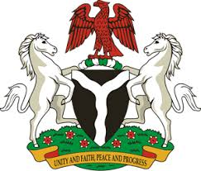
Please check against delivery
HUMAN RIGHTS COUNCIL
34TH SESSION OF THE WORKING GROUP OF THE UPR
REVIEW OF IRAN
8TH NOVEMBER, 2019
STATEMENT BY NIGERIA
Mr President,
Nigeria welcomes the delegation of the Islamic Republic of Iran to the presentation of its Third Cycle UPR National Report. We commend the Government of Iran for its continued cooperation with the UPR process and other human rights mechanisms, as well as its efforts in implementing the previous recommendations.
2. We laud the Government of Iran for its efforts and commitment to the promotion and protection of human rights, by further strengthening the country’s legal and institutional frameworks. The measures adopted by the Government of Iran, with a view to reducing poverty and enhancing the socio-economic well-being of its people are noteworthy.
3. While acknowledging the efforts of the Government of Iran in upholding human rights, and in the spirit of constructive dialogue, Nigeria wishes to make the following recommendations for the consideration of Iran:
- To continue efforts in protecting the rights of persons with disabilities, especially women and children; and
- To sustain its efforts in enhancing the socio-economic well-being of its people.
4. Finally, we wish Iran a very successful review process.
I thank you Mr President.
******

