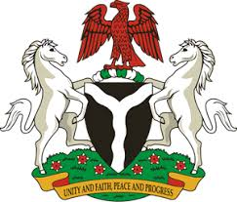
Please check against delivery
HUMAN RIGHTS COUNCIL
34TH SESSION OF THE WORKING GROUP OF THE UPR
REVIEW OF THE GAMBIA
5TH NOVEMBER, 2019
STATEMENT BY NIGERIA
Mr President,
Nigeria warmly welcomes the delegation of the Republic of the Gambia to the presentation of the country’s Third Cycle UPR National Report, and thanks it for the comprehensive update provided today. We commend the Government of the Gambia for its continued cooperation with human rights mechanism and its efforts in the implementation of previous recommendations.
2. We applaud the Government of the Gambia for its ratification of a number of international instruments for the promotion and protection of human rights. We also commend the Gambia for its efforts in strengthening the country’s legal and institutional frameworks, with a view to ensure the full enjoyment of human rights by its people.
3. While acknowledging the achievements recorded by the Gambia in the field of human rights, and the spirit of constructive dialogue, Nigeria recommends the following for the consideration of the Gambia:
- To continue its efforts in enhancing the socio-economic well-being of its people, and ensure their full enjoyment of human rights; and
- To continue to seek necessary international support to enhance its capacity for the promotion and protection of human rights.
4. In conclusion, we wish the Gambia a very successful review process.
I thank you Mr President.
******

