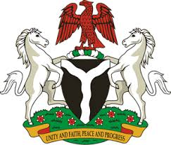
Please check against delivery
HUMAN RIGHTS COUNCIL
34TH SESSION OF THE WORKING GROUP OF THE UPR
REVIEW OF FIJI
6TH NOVEMBER, 2019
STATEMENT BY NIGERIA
Mr President,
Nigeria welcomes the delegation of the Republic of Fiji to the presentation of the country’s National Report for the Third Cycle UPR. We commend the Government of Fiji for its cooperation with human rights mechanisms and its efforts in the implementation of the recommendations it accepted during the previous review.
2. Nigeria lauds the Government of Fiji for its determination and commitment in addressing the effect of climate change, by the adoption of its first National Adaptation Plan, with a view to ensure that its people continue to enjoy basic human rights and fundamental freedoms. The Government’s ratification of a number of international instruments and its efforts in strengthening the country’s legal and institutional frameworks for the promotion and protection of human rights are worthy of commendation.
3. In the spirit of constructive dialogue, Nigeria recommends the following to Fiji:
- Not to relent in its efforts and commitment to addressing the effect of climate change, with a view to ensure enjoyment of human rights by its people; and
- To continue to strengthen its legal and institutional frameworks for the promotion and protection of human rights.
4. To conclude, we wish Fiji every success in its review process.
I thank you Mr President.
******

