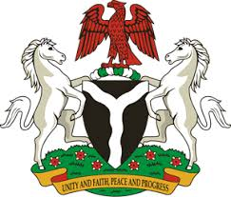
Please check against delivery
HUMAN RIGHTS COUNCIL
34TH SESSION OF THE WORKING GROUP OF THE UPR
REVIEW OF EL-SALVADOR
4TH NOVEMBER, 2019

STATEMENT BY NIGERIA
Mr Vice President,
Nigeria welcomes the delegation of the Republic of El-Salvador to the presentation of its National Report for the Third Cycle UPR. We commend the Government of El-Salvador for its continued cooperation with the UPR process and other human rights mechanisms, as well as its efforts in implementing the recommendations accepted during the previous review.
2. We note with encouragement, the various efforts of the Government of El-Salvador in strengthening the country’s legal and institutional frameworks, with a view to ensuring the promotion and protection of human rights and fundamental freedoms. We also commend El-Salvador for its determination to combat human trafficking.
3. While acknowledging El-Salvador’s efforts in upholding human rights, and in the spirit of constructive dialogue, Nigeria wishes to recommend the following to El-Salvador:
- To sustain its efforts in combatting human trafficking; and
- To continue to strengthen its legal and institutional frameworks for the promotion and protection of human rights.
4. Finally, we wish El-Salvador a very successful review process.
I thank you Mr Vice President.
******

