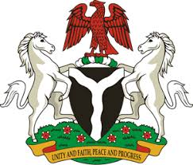
Please check against delivery
HUMAN RIGHTS COUNCIL
34TH SESSION OF THE WORKING GROUP OF THE UPR
REVIEW OF EGYPT
13TH NOVEMBER, 2019
STATEMENT BY NIGERIA
Mr President,
Nigeria warmly welcomes the delegation of the Arab Republic of Egypt to the presentation of the country’s Third Cycle UPR National Report, and thanks them for the comprehensive update provided today. We commend the Government of Egypt for its continued cooperation with human rights mechanisms and its efforts in implementing the previous recommendations.
2. In the spirit of constructive engagement, Nigeria recommends the following to Egypt:
- Continue efforts to protect its citizens from the scourge of terrorism;
- Ensure equal access for women and girls to education at all levels; and
- Enhance efforts to combat corruption and ensure accountability in this regard.
3. We extol the Government of the Egypt for its adoption of the national anti-corruption strategy, with a view to combatting corruption and promoting transparency in public services and institutions. We take positive note of the Government’s counter-terrorism measures, while recognising the imperative of upholding human rights.
4. In conclusion, we wish Egypt a very successful review process.
I thank you Mr President.
******

