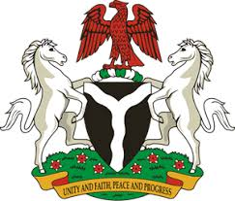
Please check against delivery

HUMAN RIGHTS COUNCIL
34TH SESSION OF THE WORKING GROUP OF THE UPR
REVIEW OF BOLIVIA
5TH NOVEMBER, 2019
STATEMENT BY NIGERIA
Mr Vice President,
Nigeria welcomes the delegation of the Plurinational State of Bolivia to the presentation of its National Report for the Third Cycle UPR. We commend the Government of Bolivia for its cooperation with human rights mechanisms, and its efforts in implementing the previous recommendations.
2. We note with encouragement, Bolivia’s poverty reduction measures, transparency and the fight against corruption, as well as efforts to ensure access to justice. The Government’s efforts to combat racism and all forms of discriminations are also commendable.
3. In the spirit of constructive dialogue, Nigeria wishes to make the following recommendations for the consideration of Bolivia:
- Not to relent in its efforts to ensure the promotion and protection of the human rights of its people, particularly the vulnerable groups; and
- To sustain its efforts in enhancing the socio-economic well-being of its people.
4. Finally, we wish Bolivia a very successful review process.
I thank you Mr Vice President.
******

