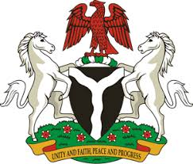
Please check against delivery
HUMAN RIGHTS COUNCIL
34TH SESSION OF THE WORKING GROUP OF THE UPR
REVIEW OF ANGOLA
7TH NOVEMBER, 2019
STATEMENT BY NIGERIA
Mr President,
Nigeria warmly welcomes the delegation of the Republic of Angola to the presentation of the country’s Third Cycle UPR National Report, and thanks them for the update provided today. We commend the Government of Angola for its continued cooperation with human rights mechanisms and its efforts in implementing the previous recommendations.
2. Nigeria applauds the Government of Angola for the ratification of a number of international instruments, and the efforts to strengthen the country’s legal and institutional frameworks for the promotion and protection of human rights. We also commend Angola for its commitment to sustainable development and poverty alleviation, as well as its efforts at combatting corruption.
3. In the spirit of constructive dialogue, Nigeria recommends the following for the consideration of Angola:
- To continue its poverty alleviation efforts and ensure sustainable development, with a view to improving the general welfare of its citizens; and
- To continue to strengthen its legal and institutional frameworks for the promotion and protection of human rights.
4. In conclusion, we wish Angola a very successful review process.
I thank you Mr President.
******

