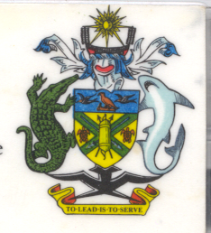
Statement
by H.E. Barrett Salato
Ambassador and Permanent Representative
Solomon Islands at Italy’s Review
34th Session of the UPR, Geneva 4 November 2019
Check Against Delivery

Mr. President, Solomon Islands welcomes the delegation of Italy and thanks them for the positive engagement during this UPR process, the respect for human rights and the broad commitment to cooperating with the Human Rights Council and all other international mechanisms.
We recognise the work of Italy to progressively implement human rights. We acknowledge efforts and initiatives of Italy to implement 153 out of 176 recommendations accepted under the Second Cycle of UPR in 2014.
We also recognise the country's plans as it relates to human rights around non-discrimination, right to life, liberty and security of the person.
We note Italy’s compassion towards refugees as well as asylum-seekers. We acknowledge its respect for the right to privacy and family life, as well as participation in public and political life through, for example, the first National Action Plan adopted in December 2016.
Solomon Islands noted Italy’s full engagement in the dissemination of the CERD Committee Concluding Observations.
Solomon Islands recommends that Italy strengthens the capacity of the National Office against Racial Discrimination to ensure all forms of discrimination are eliminated from its society.
Solomon Islands recommends that Italy establishes an independent National Human Rights Institution conforming with Paris Principles.
Salomon Islands wishes the delegation of Italy a successful UPR.
I thank you.

