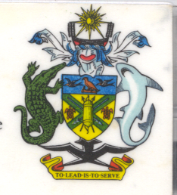
Statement
by H.E. Barrett Salato
Ambassador and Permanent Representative of
Solomon Islands at Gambia’s Review

34th Session of the UPR, Geneva 5 November 2019

Check Against Delivery

Mr. President, Solomon Islands welcomes the delegation of Gambia and thanks them for the positive engagement during this UPR process and for the commitment to the progressive realization of the rights and freedoms of all persons.

We also underscore the country's significant legislative reforms they undertaken since the last review.

We acknowledge that the Government has ratified international human rights treaties such as UN Treaty on the Prohibition of Nuclear Weapons, ratified in 2018; International Convention on the Protection of the Rights of All Migrant Workers and Members of their Families (ICRMW) in 2018; International Convention for the Protection of All Persons from Enforced Disappearance (CED) in 2018; The Optional Protocol to the Convention on the Rights of the Child on the Involvement of Children in Armed Conflict, ratified in April 2008.

We acknowledge that Gambia has taken legislative actions such as prohibition of child marriage under Children’s (Amendment) Act 2016 with jail terms of up to 20 years for convicted offenders. Gambia has also banned Female Genital Mutilation under both the Women’s (Amendment) Act 2015 and the Children’s Act 2005 with significant jail terms and fines for convicted offenders.

We recommend that Gambia takes steps to implement these and other laws, improve community engagement, and raises awareness to promote the best interests of the child, as well as protect women and children from harmful practices.

Salomon Islands wishes the delegation of Gambia a successful UPR.

I thank you.

