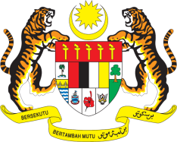

STATEMENT BY MALAYSIA
Review of Slovenia
34th Session of the UPR Working Group

Thank you, Mr. President.

Malaysia welcomes the distinguished delegation of Slovenia and thanks them for the presentation of their national report.

- We commend Slovenia for the progress made in the promotion and protection of human rights as well as the efforts undertaken in implementing the accepted recommendations from previous reviews including those made by Malaysia. We encourage Slovenia to continue its positive efforts in further promoting and protecting the human rights of its population including minorities. In the spirit of constructive engagement, Malaysia would like to present the following recommendations for the consideration of Slovenia:

2.1. Ensure the availability and accessibility of palliative care for all older persons;

2.2. Ensure equal access to quality education for all students;

2.3. Strengthen measures to prevent and curb all forms of violence against women including domestic violence, by among others ensuring effective remedies to victims; and

2.4. Ensure comprehensive legislation to protect the rights of minorities.

- Malaysia wishes Slovenia a successful UPR.

I thank you, Mr. President.

GENEVA
12 November 2019

