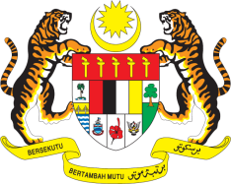

Statement by His Excellency Dato’ Dr. Ahmad Faisal Muhamad
Permanent Representative of Malaysia to the United Nations Office and Other International Organisations
34th Session of the UPR Working Group
Review of Kazakhstan

Thank you Madam Vice President.

Malaysia warmly welcomes the delegation of Kazakhstan and thanks them for the presentation of their national report.

- Malaysia commends Kazakhstan for the broad consultations involving various stakeholders for its UPR, and for the progress in the promotion and protection of human rights in the country as attested by effective implementation of several national policies/programmes. We welcome the roadmap for reproductive health and efforts to provide services through health centres targeted at specific segments of the population. These efforts must be sustained and strengthened with adequate resources and necessary legislations.

- In the spirit of constructive engagement, Malaysia would like to propose the following recommendations for Kazakhstan’s consideration

3.1. One: Continue its efforts in further enhancing the protection of economic, social and cultural rights of its people; and

3.2. Two: Strengthen efforts to ensure affordable and quality health and social services, to improve the overall well-being of children, women and older persons.

I thank you, Madam Vice President.

GENEVA
7 November 2019

