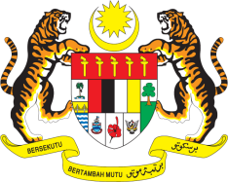

STATEMENT BY MALAYSIA
34th Session of the UPR Working Group
Review of Iraq

Thank you, Mr. President.

Malaysia thanks the delegation of Iraq for the presentation of their national report.

2. Malaysia welcomes Iraq’s efforts in the promotion and protection of human rights in the country since the last review. We also note that Iraq has launched national strategies and programmes on poverty reduction, reproductive health, nutrition and food safety, among others. We believe that effective implementation of these programmes would further improve the well-being and livelihood of its population.

3. In this respect, we encourage Iraq to continue its positive efforts and would like to propose the following recommendations for the consideration of Iraq:

  - One: Strengthen measures to ensure the rights of persons with disabilities including through proper legislation, infrastructure and facilities; and

  - Two: Introduce robust and targeted policies to promote gender equality and;

  - Three: Strengthen empowerment of women through education and skills training.

4. Malaysia wishes Iraq a successful review.

Thank you.

GENEVA
11 November 2019

