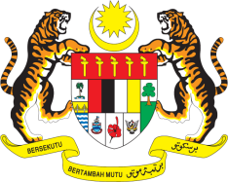

STATEMENT BY MALAYSIA
34th Session of the UPR Working Group
Review of Angola

Thank you, Mr. President.

Malaysia thanks the delegation of Angola for presenting its national report.

- Malaysia commends Angola for its efforts to promote and protect human rights of its people including through the adoption of several laws in the area of civil, political, economic, social and cultural rights during the review period. Malaysia welcomes Angola’s Human Rights Strategy 2019–2022 and look forward to its effective implementation.

- In further strengthening Angola’s human rights protection, Malaysia wishes to make the following recommendations:

  - One: Strengthen measures to address poverty and implement targeted policies to improve livelihood of its people;

  - Two: Increase efforts to ensure universal access to basic health-care services including by allocating adequate resources to the health sector; and

  - Three: Improve infrastructure and increase health-care facilities especially in rural areas.

- We wish Angola success for its future undertakings in the field of human rights.

I thank you, Mr. President.

GENEVA
7 November 2019

