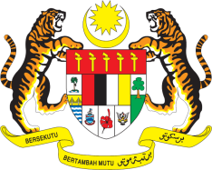

STATEMENT BY MALAYSIA
34th Session of the UPR Working Group
Review of Egypt

Thank you, Mr. President.

Malaysia welcomes the distinguished delegation of Egypt and congratulates them for the presentation of their national report.

2. Malaysia welcomes efforts undertaken by the Government to improve human rights situation in the country particularly those related to the rights of children as well as those aimed to ensure empowerment of women, young people and persons with disabilities. We encourage Egypt to continue its efforts to improve livelihood of its people. In the spirit of constructive engagement, Malaysia recommends the following:

2.1. Develop and implement a national human rights strategy aimed at the promotion and protection of human rights;

2.2. Continue efforts to reduce poverty particularly in rural areas; and

2.3. Ensure efforts to guarantee access to safe drinking water and sanitation for all, including those residing in rural areas.

Malaysia wishes Egypt a successful review.

I thank you, Mr. President.

GENEVA
13 November 2019

