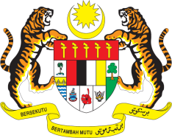

STATEMENT BY MALAYSIA
34th Session of the UPR Working Group
Review of Bolivia

Thank you, Mr. President.

Malaysia congratulates the delegation of Bolivia for the presentation of their national report. Malaysia welcomes the multi-stakeholder consultation process undertaken by Bolivia in the preparation of its National Report.

- Numerous national initiatives by Bolivia since its second UPR have substantially improved human rights situation in the country. Malaysia welcomes in particular efforts to improve livelihood of youth through the implementation of the Multi-sectoral Plan for the Comprehensive Development of Young People 2016–2020.

- While progress has been made, Malaysia is of the view that further improvements could be made in areas such as employment for women. In this regard, we wish to make the following recommendations:

3.1. One: Improve access to decent work for all women and implement measures to increase participation of women in the formal labour market; and

3.2 Two: Take urgent effective measures to curb exploitation of women and girls in domestic work including by providing victims access to effective remedies.

Mr. President,

- Everyone in Bolivia could lead a full and meaningful life, in a fair and inclusive society with greater and continued commitment from the Government of Bolivia. In this respect, Malaysia wishes Bolivia the best in its UPR undertakings.

I thank you, Mr. President.

GENEVA
5 November 2019

