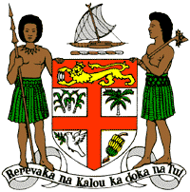
PERMANENT MISSION OF THE REPUBLIC OF FIJI TO THE UNITED NATIONS
OFFICE AND OTHER INTERNATIONAL ORGANISATIONS AT GENEVA
34TH CYCLE UNIVERSAL PERIODIC REVIEW
ANGOLA

Thank you Mr. (Mr/Ms. Vice) President.

Fiji welcomes the delegation of Angola and thanks the delegation for the presentation of its national report. Fiji congratulates Angola on the many achievements specified therein.

Fiji commends Angola’s commitment to increasing the participation of rural women in the formulation of policies in areas that affect them, such as access to land, agricultural inputs and foodstuffs, and to empower and enable them to develop sustainable agricultural cooperatives.

Fiji further commends Angola on its National Women’s Consultation Forum, National Rural Women’s Development Programme 2015–2017, National Policy on Gender, and the Agrarian Reform Programme and the National Strategy for Combating Poverty.

Fiji recommends that Angola continue to prioritise the empowerment of women and break down barriers to equality, with a view to ensure all persons equal citizenry.

Fiji notes the absence of information in the national report on Angola’s domestic initiatives to address the causes and effects of climate change. In this regard, Fiji recommends that Angola ensure that women, children, and persons with disabilities are meaningfully engaged in the development of legislation, policies and programs on climate change and disaster risk reduction.

Thank you, Mr. (Mr/Ms. Vice) President.

