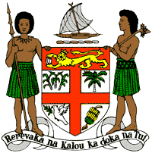
PERMANENT MISSION OF THE REPUBLIC OF FIJI TO THE UNITED NATIONS
OFFICE AND OTHER INTERNATIONAL ORGANISATIONS AT GENEVA.
34TH CYCLE UNIVERSAL PERIODIC REVIEW
RECOMMENDATION FOR MADAGASCAR
Thank you Mr. (Mr/Ms. Vice-) President.
Fiji welcomes the delegation of Madagascar and thanks the delegation for the presentation of its national report and its continued engagement in this UPR process.
Fiji commends Madagascar for adopting both a law on the worst forms of child labour and the National Action Plan against Child Labour.
Fiji further commends Madagascar for its commitment to environmental protection and the enactment of legislation and national plans to address this. Fiji notes that Madagascar does not specify strategies to address the causes and effects of climate change. Climate change affects us all and requires a unified effort to combat against it.
Fiji, therefore, makes the following two recommendations:
- Firstly, that Madagascar implement and continue to strengthen initiatives aimed at preventing and protecting against child labour and child sexual exploitation.

- Secondly, that Madagascar ensure that women, children, and persons with disabilities are meaningfully engaged in the development of legislation, policies and programs on climate change and disaster risk reduction.
Fiji wishes Madagascar every success in its UPR.
Thank you Mr. (Mr/Ms. Vice-) President.

