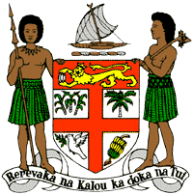
PERMANENT MISSION OF THE REPUBLIC OF FIJI TO THE UNITED NATIONS
OFFICE AND OTHER INTERNATIONAL ORGANISATIONS AT GENEVA
34TH CYCLE UNIVERSAL PERIODIC REVIEW
KAZAKHSTAN

Thank you Mr (Vice) President.

Fiji welcomes the delegation of Kazakhstan and thanks the delegation for the presentation of its national report.

Fiji commends Kazakhstan on retaining and continuing its moratorium on the death penalty. Fiji notes that Kazakhstani is currently working to narrow the scope of the death penalty in its law.

Fiji further commends Kazakhstan on its 2013-2020 Action Plan and 2014 Presidential Decree which aims to facilitate a transition to a ‘Green Economy’. We note that the transition is ongoing and that Kazakhstan is committed to achieving its planned target indicators by 2020, and Fiji encourages Kazakhstan in this regard.

Fiji makes the following recommendations:

- That Kazakhstan, in narrowing the application of the death penalty under its law, also consider its complete abolition; and

- That Kazakhstan ensure that women, children, and persons with disabilities are meaningfully engaged in the development of legislation, policies and programs on climate change and disaster risk reduction.

We wish the delegation every success in its review. Thank you, Mr. (Vice) President.

