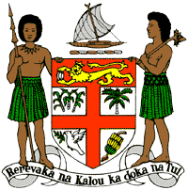

**PERMANENT MISSION OF THE REPUBLIC OF FIJI TO THE UNITED NATIONS**

**OFFICE AND OTHER INTERNATIONAL ORGANISATIONS AT GENEVA**

**34TH CYCLE UNIVERSAL PERIODIC REVIEW**

**ISLAMIC REPUBLIC IRAN**

Thank you Mr (Vice) President.

Fiji welcomes the delegation of the Islamic Republic of Iran and thanks it for the presentation of its national report and continued engagement in this UPR process. Fiji makes the following recommendations:

1. Firstly, intensify its efforts to ratify the UN Convention against Torture and other Cruel, Inhumane and Degrading Treatment and Punishment;
2. Secondly, effectively remove barriers for access to justice for women, children, persons with disabilities and persons in vulnerable situations.
3. We note Iran’s efforts in reducing the mortality rate of infants, children, pregnant mothers through free maternal and child health benefits and recommend that Iran further develop its existing policies to provide adequate and accessible maternal and child health care for all women and children, especially those in vulnerable situations.
4. Lastly, Fiji recommends that Iran ensure that women, children, and persons with disabilities are meaningfully engaged in the development of legislation, policies and programs on climate change and disaster risk reduction.

I thank you, Mr. (Vice) President.