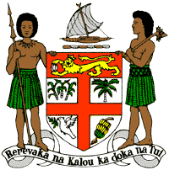
PERMANENT MISSION OF THE REPUBLIC OF FIJI TO THE UNITED NATIONS
OFFICE AND OTHER INTERNATIONAL ORGANISATIONS AT GENEVA
34 TH CYCLE UNIVERSAL PERIODIC REVIEW
THE REPUBLIC OF THE GAMBIA

Thank you Mr. (Vice-) President.
Fiji welcomes the delegation of the Republic of the Gambia and thanks it for its continued engagement in the UPR process.
Fiji congratulates the Republic of the Gambia for ratifying the United Nations Convention against Torture. It is a laudable step to strengthen protections against torture and cruel, inhuman or degrading treatment or punishment.
Fiji also congratulates the Republic of the Gambia both for ratifying the Second Optional Protocol to the ICCPR, and for placing a moratorium on the use of the death penalty. Given the Republic of the Gambia’s substantial efforts to cease the use of the death penalty, Fiji recommends that the Republic of the Gambia consider formally abolishing the death penalty.
Fiji notes the absence of information in the national report on Gambia’s domestic initiatives to address the causes and effects of climate change. In this regard, Fiji recommends that Gambia ensure that women, children, and persons with disabilities are meaningfully engaged in the development of legislation, policies and programs on climate change and disaster risk reduction.
Thank you Mr. (Vice-) President.

