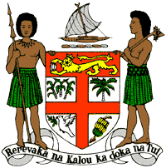
PERMANENT MISSION OF THE REPUBLIC OF FIJI TO THE UNITED NATIONS
OFFICE AND OTHER INTERNATIONAL ORGANISATIONS AT GENEVA
34TH CYCLE UNIVERSAL PERIODIC REVIEW
EL SALVADOR

Thank you Mr (Vice) President.

Fiji welcomes the delegation of El Salvador and thanks the delegation for the presentation of its national report and its continued engagement in this UPR process.

Fiji commends El Salvador for the adoption of an Environment Act, an Environment Policy and a National Plan on Climate Change. Fiji acknowledges the progress made in improving sanitation, eliminating 86.1 percent of the country’s contaminated waste and reducing the production and consumption of ozone-depleting substances by 45%.

Fiji further commends El Salvador for its efforts towards preventing all forms of discrimination in the civil service on the grounds of gender identity or sexual orientation and increasing the gravity of the offences of homicide and criminal threat when they are motivated by ‘hatred of gender identity and expression or sexual orientation’.

Fiji makes the following recommendations:

- That El Salvador ensure the full and effective participation of women, children and persons with disabilities in the execution of its National Plan on Climate Change at all levels of implementation and decision making; and

- That El Salvador continue to step up its efforts to combat violent crimes, especially those deriving from discrimination based on gender identity and expression or sexual orientation.

We wish the delegation every success in its review. Thank you, Mr. (Vice) President.

