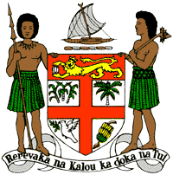
PERMANENT MISSION OF THE REPUBLIC OF FIJI TO THE UNITED NATIONS
OFFICE AND OTHER INTERNATIONAL ORGANISATIONS AT GENEVA
34 TH CYCLE UNIVERSAL PERIODIC REVIEW
EGYPT

Thank you Mr./Madam (Vice-) President.
Fiji welcomes the delegation of Egypt and congratulates the delegation for the achievements in the implementation of the recommendations from its previous cycle, especially in relation to the work of the National Council for Women.
Fiji offers the following three recommendations.
- That Egypt continue to ensure that women, children, and persons with disabilities, are meaningfully engaged in the development of legislation and programs on climate change and disaster risk reduction.

- That Egypt continue to strengthen its efforts to prevent and refrain from all acts of intimidation or reprisal against those who cooperate with the UN, its representatives and mechanisms in the field of human rights.

- Lastly, integrate comprehensive, age-appropriate education on reproductive health and life skills into the national educational curricula and ensure the necessary resources and training for its full and effective implementation, in accordance with the national Strategy for Population and Development.

We wish the delegation every success.
I thank you.

