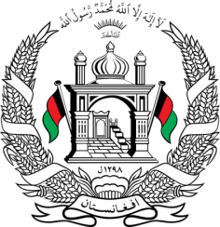
Permanent Mission of Islamic Republic of Afghanistan
34th Session of the UPR Working Group
Statement at the 3rd UPR of Italy
November 04, 2019
Thank you, Mr. President!
Afghanistan welcomes the distinguished delegation of Italy and thanks them for detailed and informative presentation of their third report.
My delegation congratulates Italy among other things for the adoption of Freedom of Information act in 2016 and adoption of National Action Plan for the Business and Human rights.
While appreciating Italy’s human rights achievements, my delegation recommends the following:
- Specific attention to be given to the most vulnerable groups among migrant and asylum seeker populations such as women and under aged children,
- Informing all relevant authorities of the principle of nonrefoulement and encouraging respect for this principle, which is separate from the right to seek asylum.
We wish Italy every success in the UPR review process.
I thank you, Mr. President!

