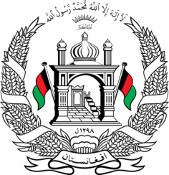
Permanent Mission of Islamic Republic of Afghanistan
34th Session of the UPR Working Group
Statement at the 3rd UPR of Iraq
November 11, 2019
Thank you, Madam Vice President!
Afghanistan welcomes the distinguished delegation of Iraq and thanks them for their detailed presentation of the third national report.
My delegation appreciates Iraq for the human rights achievements made since the last UPR session by reactivation of the national HR plan; development of institutional structures for HR; expanding mechanisms for receiving citizens' complaints by opening offices in national government institutions.
Madam Vice President;
My delegation recommends to Iraq the followings:
- Take appropriate measures to promote access to education for marginalized groups; to provide access to education to migrants, refugees and internally displaced persons; to increase access of women and girls to education; and to eliminate harmful practices that hindered access to education and retention of girls;
- To take necessary steps to enact the Children's Code and take appropriate measures for its effective implementation
We wish Iraq every success in the UPR review process.
I thank you, Madam vice President!

Compilation, Page 7, para 49
Stakeholders, Page 2, para 13

