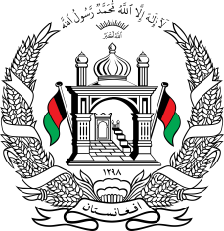
Permanent Mission of Islamic Republic of Afghanistan
34th Session of the UPR Working Group
Statement at the 3rd UPR of Egypt
November 13, 2019
Mr. President,
Afghanistan warmly welcomes the distinguished Minister of Parliamentary affairs of Egypt and his accompanying delegation to this meeting.
We acknowledge Egypt’s effort in addressing the impacts of terrorism on the enjoyment of human rights in the Human Rights Council, and value their initiatives aimed at promoting moderation, and religious tolerance.
In the spirit of constructive engagement, we wish to make the following rec-ommendations:
- Create a safe and enabling environment for the operation of the civil society and human rights defenders, facilitate their work and protect them against harassment and intimidation.
- Enhance efforts to combat corruption and ensure accountability in this regard.
- Take measures to protect refugees and migrants from violence and attempts on their lives and further promote tolerance among local communities.
- Continue efforts to ensure the delivery of quality education for all with special focus on vulnerable groups.
Finally, Afghanistan wishes Egypt every success in this cycle of the UPR review.
I thank you, Mr. President!

