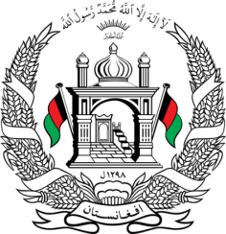
Permanent Mission of Islamic Republic of Afghanistan
34th Session of the UPR Working Group
Statement at the 3rd UPR of Angola
November 7, 2019
Mr. President!
Afghanistan cordially welcomes the distinguished Angolese delegation to this meeting.
We welcome the submission of a midterm report on the implementation of the recommendations from the previous cycle and other steps taken to improve the human rights situation in the country.
While we congratulate the government for reducing the gender gap in education at the primary level, we recommend the government to intensify its efforts to improve equal access to education for all, especially to vulnerable groups such as women, minorities, children with special needs and those in rural areas.
We highly value the State’s policy to accommodate large numbers of migrants and asylum seekers within its territory, but to address the exisitng concerns we recommend Angola to ensure the implementation of the law on the right to asylum and refugee status, put in place fair and effective asylum procedures, and swiftly issue and renew identification documents for asylum seekers and refugees.
We further recommend the government to Ensure that detention of asylum seekers and refugees is used only as a last resort and that those detained in reception centres were provided with legal safeguards.

Finally, Afghanistan wishes Angola a successful review.
Thank you Mr. President

