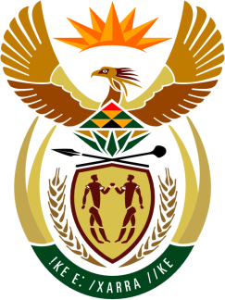

SOUTH AFRICAN PERMANENT MISSION
TO THE UNITED NATIONS
AND OTHER INTERNATIONAL ORGANISATIONS

34th SESSION OF THE WORKING GROUP ON THE
UNIVERSAL PERIODIC REVIEW

Review of ITALY

04 NOVEMBER 2019

PALAIS DES NATIONS

Check against delivery

President,

South Africa welcomes the Honourable Under-Secretary of State and the distinguished delegation of Italy to this UPR Session.

In order to ensure progress in promoting and protecting human rights, we respectfully recommend that Italy:
- Expedite and finalise the setting up of a National Human Rights Institution in accordance with the Paris Principles.
- Strengthen the resources allocated to the National Plan of Action against Racism, Xenophobia and Related Intolerance.
- Review Law No. 132 of 2018 on the detention of asylum seekers to align it with international refugee law and human rights law.
- Revive and implement the national strategy to counter discrimination against LGBTI people.

President,

My delegation congratulates Italy on human rights training provided to law enforcement officials; on amendments to the criminal code to protect victims of domestic and gender-based violence; on ratifying international and human rights instruments prohibiting racial discrimination; and on the setting up of an advisory LGBTI National Working Group.

South Africa respectfully reminds the delegation that rescue is a fundamental obligation contained in all major international agreements on protecting life at sea. The human rights of those rescued at sea ought not to be put at risk due to disagreements about disembarkation, and the state should refrain from any actions that would inhibit captains of vessels from adhering to these long-standing international obligations.

We wish Italy all success in this review session.

I thank you.

