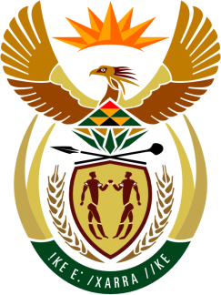

SOUTH AFRICAN PERMANENT MISSION
TO THE UNITED NATIONS
AND OTHER INTERNATIONAL ORGANISATIONS

34th SESSION OF THE WORKING GROUP ON THE
UNIVERSAL PERIODIC REVIEW

Review of Iraq

11 November 2019

PALAIS DES NATIONS

Check against delivery

President,

South Africa welcomes the distinguished delegation of Iraq to this UPR Session.

South Africa wishes to respectfully recommend the following:

- To prioritize national reconciliation and transitional justice processes, including by establishing a strategy to address the human rights violations perpetrated by all parties to the armed conflict.

- Maintain efforts towards ensuring the full domestic implementation of the provisions of CEDAW and align all domestic laws with human rights instruments, which Iraq is a State party to.

- Further enhance measures, in cooperation with the international community, to protect and promote the rights of the child, including through strengthening the educational system and the provision of adequate food, housing and health services.

President,

South Africa welcomes the adoption of the various national strategies and related plans notably its national development plan as well as poverty reduction strategy for the period 2018–2022.

South Africa welcomes the inclusion of Human Rights concerns in Educational programmes and congratulates Iraq for these initiatives.

South Africa wishes Iraq all the success with its Review.

I thank you.

