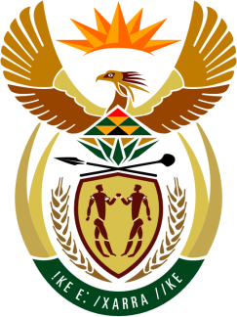

SOUTH AFRICAN PERMANENT MISSION
TO THE UNITED NATIONS
AND OTHER INTERNATIONAL ORGANISATIONS

34th SESSION OF THE WORKING GROUP ON THE
UNIVERSAL PERIODIC REVIEW

Review of The Gambia

5 November 2019

PALAIS DES NATIONS

Check against delivery

President,

South Africa welcomes the distinguished delegation of The Gambia to this UPR Session.

South Africa wishes to respectively make the following recommendations:

- Expedite the implementation of the 2018 National Development Plan that promises to restore good governance, respect for human rights and the rule of law for all citizens, while working towards eradicating extreme poverty and hunger.

- Adopt the draft Disability Bill and continue to strengthen the implementation of the Disability Advocacy Strategy to integrate the interests of persons with disabilities in the country’s development agenda.

- Through the recently established Ministry of Women, Children and Social Welfare continue to strengthen efforts aimed at the promotion of gender equality, access to social protection through educational campaigns, while paying specific attention to the needs of rural women.

President,

South Africa further commends the Government of The Gambia for the political reforms that have resulted in the enhancement of protection and promotion of human rights as well as to the widening of the democratic space.

South Africa welcomes and congratulates The Gambia for signing and ratifying the following instruments: Convention against Torture and Other Cruel, Inhuman or Degrading Treatment or Punishment (CAT) and the Second Optional Protocol to the International Covenant on Civil and Political Rights (ICCPR) aimed at the abolishment of the death penalty.

South Africa wishes The Gambia a successful review.

I thank you.

