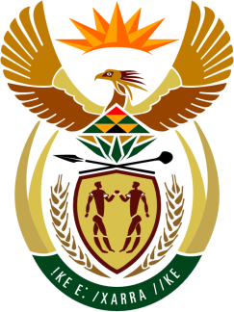

SOUTH AFRICAN PERMANENT MISSION
TO THE UNITED NATIONS
AND OTHER INTERNATIONAL ORGANISATIONS

34th SESSION OF THE WORKING GROUP ON THE
UNIVERSAL PERIODIC REVIEW

Review of EGYPT

13 November 2019

PALAIS DES NATIONS

Check against delivery

Mr President,

South Africa welcomes the distinguished delegation of Egypt to this UPR Session.

South Africa wishes to respectively make the following recommendations:

- To continue its cooperation with international as well as regional human rights mechanisms.

- That Egypt share the lessons learned from it past year as Chair of the AU in respect of cooperation with international and regional human rights mechanisms.

South Africa congratulates Egypt for its leadership of the African Union during the past year notably heading the process of institutional reform to consolidate the continent’s efforts in Regional and Continental integration.

My delegation welcomes Egypt’s various efforts to promote mediation of conflicts on the continent which serves to consolidate and uphold human rights, also in the context of the various Regional Economic Communities.

We also welcome Egypt’s chairship of the Committee of African Heads of State and Government on Climate Change (CAHOSCC) dealing with the critical challenges posed by climate change also to ensure the success of activating the Paris Accord on Climate Change.

South Africa wishes Egypt a successful review.

I thank you.

