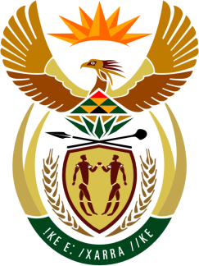

SOUTH AFRICAN PERMANENT MISSION
TO THE UNITED NATIONS
AND OTHER INTERNATIONAL ORGANISATIONS

34th SESSION OF THE WORKING GROUP ON THE
UNIVERSAL PERIODIC REVIEW

Review of THE PLURINATIONAL STATE OF BOLIVIA

05 NOVEMBER 2019

PALAIS DES NATIONS

Check against delivery

President,

South Africa welcomes the distinguished Bolivian delegation to this UPR Session.

In order to ensure progress in promoting and protecting human rights, we respectfully recommend that Bolivia:
- Strengthen implementation of the Multi-Sectoral Plan to Combat Racism and All Forms of Discrimination.
- Enhance efforts to promote women entrepreneurship in urban and rural areas.
- Sustain efforts to implement the Declaration on the Rights of Peasants and Other Working People in rural areas.
- Criminalise hate crimes based on race, sexual orientation and gender identity.

President,

My delegation welcomes Bolivia’s adoption of the Comprehensive Act on Guaranteeing Women a Life Free of Violence, and the allocation of resources to strengthen the capacity of the police force to implement it. We congratulate Bolivia in halving the number of people living in extreme poverty between 2006 and 2018, a praiseworthy achievement. We also applaud the declaration of the Decade for Bolivian People of African Descent up to 2024, and the measures implemented to ensure the full enjoyment of their human rights by Bolivians of African descent.

We wish Bolivia all success in this review session.

I thank you.

