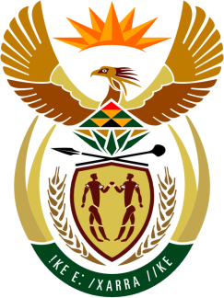

SOUTH AFRICAN PERMANENT MISSION
TO THE UNITED NATIONS
AND OTHER INTERNATIONAL ORGANISATIONS

34th SESSION OF THE WORKING GROUP ON THE
UNIVERSAL PERIODIC REVIEW

Review of ANGOLA

07 NOVEMBER 2019

PALAIS DES NATIONS

Check against delivery

President,

South Africa welcomes Honourable Minister Manuel Domingos Augusto and the distinguished delegation of Angola to this UPR Session.

In order to ensure progress in promoting and protecting human rights, we respectfully recommend that Angola:

- Consider extending the limited mandate and increase the financial resources as well as expedite the adoption of the legal framework required for the Office of the Ombudsman to effectively comply with the principles relating to the status of national institutions for the promotion and protection of human rights (the Paris Principles).

- Develop and implement a national strategy to counter discrimination against vulnerable people and groups, women, people with disabilities and LGBTI people.

President,

My delegation commends Angola for the adoption of its new National Development Plan for 2018–2022 and the Integrated Municipal Programme of Rural Development and the Fight against Poverty 2018–2022, by Presidential Decree 140/18 of 6 June.

My delegation further congratulates Angola on ratifying, in 2019, the various International Treaties pertaining.

My delegation further commends Angola on the approval of a new Criminal Code, which introduced important changes on human rights issues, and Criminalises discriminatory acts on most grounds.

We wish Angola all success in this review session.

I thank you.

