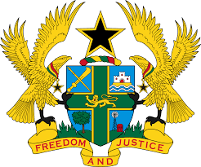

STATEMENT BY GHANA DELIVERED BY H.E RAMSES JOSEPH CLELAND,
AMBASSADOR AND PERMANENT REPRESENTATIVE, TUESDAY 5TH NOVEMBER, 2019

REVIEW OF THE GAMBIA

Thank you, Mr. President,

Ghana extends a warm to the distinguished delegation of The Gambia to the UPR Working Group.

We commend the progress made by The Gambia in the last couple of years to promote and protect human rights and fundamental freedoms albeit the monumental challenges and setbacks inherited by the new democratic dispensation. We note in particular ratification of the Convention against Torture and Other Cruel, Inhuman or Degrading Treatment or Punishment (CAT) and the ICRMW in 2018, as well as the re-establishment of membership of the Rome Statute of the ICC.
To further expand the democratic frontiers of The Gambia, Ghana wishes to make the following three recommendations:
- Continue with the ongoing institutional and legal reforms contained in the National Development Plan 2018-2021 aimed at addressing the backlog of state reports to treaty bodies;
- Continue with the ongoing review of domestic laws in line with international best practices and obligations;

- Consider ratifying the Optional Protocol to the International Covenant on Economic, Social and Cultural Rights at the earliest convenience.

Ghana wishes The Gambia a successful UPR outcome.

I thank you.

