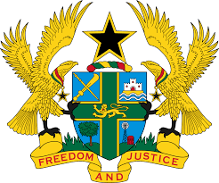

STATEMENT BY GHANA DELIVERED BY MR. ALEXANDER GRANT NTRAKWA,
DEPUTY PERMANENT REPRESENTATIVE, THURSDAY 7TH NOVEMBER, 2019

REVIEW OF ANGOLA

Thank you, Mr. President

Ghana warmly welcomes the delegation of Angola to the UPR Working Group.

My delegation commends the government of Angola for their commitment to upholding the rule of law, human rights and fundamental freedoms. We note with appreciation the recent ratification by Angola of a number of human rights treaties, including the Convention Against Torture, and the International Convention on the Elimination of All Forms of Racial Discrimination.

Ghana wishes to make the following three recommendations:
- Consider enacting a comprehensive legislation that provides full and effective protection against discrimination in all forms, and which contains a comprehensive list of prohibited grounds of discrimination.

- Take steps to ensure that the juvenile justice system applies to children of up to 18 years of age and is provided with adequate human, technical and financial resources.

- Consider ratifying the Optional Protocol to the Convention Against Torture at the earliest convenience.

Ghana wishes Angola every success with the UPR.

I thank you.

