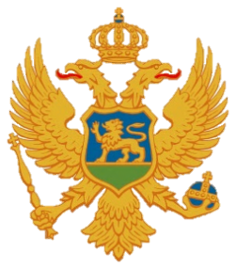

Statement of Montenegro
UPR 3rd cycle, Review of San Marino,
Geneva, 6 November 2019

Montenegro welcomes the distinguished delegation of San Marino and thanks for the presentation of its national report.
We note with appreciation the successful implementation of our recommendations given during the second UPR review. We also welcome a significant number of ratified international instruments in the field of human rights. We acknowledge developments regarding the national laws, particularly welcoming the introduction of the new legal provisions related to violence against women, gender and domestic violence and the introduction of a prohibition of discrimination based on gender identity.
Conscious of the size of the state administration of San Marino we take note of the overdue for regular reports to the respective UN Treaty bodies and call on more active engagement in the future.
Montenegro recommends the following:
1) to establish the national human rights institution;
2) to raise the minimum age for military services in all circumstances to 18 years.

We wish to San Marino the successful outcome of the review.
I thank you.

