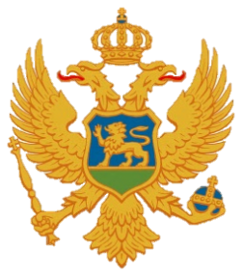

Statement of Montenegro
UPR 3rd cycle, Review of Madagascar,
Geneva, 11 November 2019

Montenegro welcomes the distinguished delegation of Madagascar and thanks for the presentation of its national report.
We welcome significant institutional and legislative developments that have been made. We note with appreciation the ratification of the Second Optional Protocol to the ICCPR, aiming at the abolition of the death penalty, as we recommended. We commend existing cooperation with the UN human rights bodies and mechanisms while acknowledging the overdue for a number of initial or regular reports. We call on the Government to invest more efforts to change this practice.
We express our concern about reports that children were engaged in domestic work, agricultural work and mining and were subjected to commercial sexual exploitation. We encourage the Government to take necessary steps towards the equal rights of women and men in all matters relating to marriage and family relations, as well as to inheritance, divorce, and custody of children. We note as well that Madagascar does not have national asylum legislation and refugee status determination procedures consistent with relevant international standards.
Montenegro recommends the following:
- to ratify Convention on the Prevention and Punishment of the Crime of Genocide;
- to reduce maternal mortality by increasing the access of women and girls to basic health-care services, and ensure sufficient resources to promote and protect women’s and girls’ reproductive health.
I thank you.

