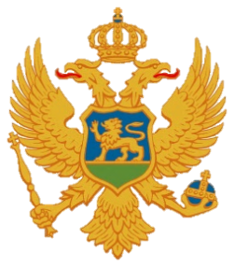

Statement of Montenegro
UPR 3rd cycle, Review of the Republic of Italy,
Geneva, 4 November 2019

Montenegro welcomes the distinguished delegation of the Republic of Italy and thanks for the presentation of its national report.
We highly appreciate the implementation of the recommendations given by Montenegro in the previous UPR cycle. We welcome significant institutional and legislative developments made in the previous period, but also we acknowledge the need for further measures regarding the human rights issues as noted by respective UN human rights Treaty Bodies.
We welcome that Italy reiterated its commitment to establish a fully independent national human rights institution in accordance with the Paris Principles.
Montenegro recommends the following:
- taking into account of the high dropout rates in the last two years of high school, to adopt comprehensive measures to promote access to education and to reduce the number of school dropouts, with focus on its south;
- to formulate a comprehensive strategy for preventing and combating violence against children.
I thank you.

