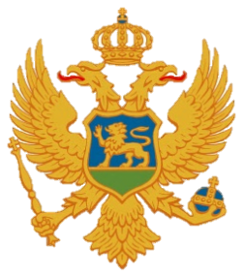

Statement of Montenegro
UPR 3rd cycle, Review of Iraq,
Geneva, 11 November 2019

Montenegro welcomes the distinguished delegation of the Republic of Iraq and thanks for the presentation of its national report.
We express our serious concern because of numbers of people who have been killed or wounded during the recent protests and call on that those who are responsible for such acts to be held accountable and perpetrated without delay.
We welcome the progress made concerning the institutional, legislative and strategical framework for human rights. We appreciate the efforts made by the Iraqi Government despite serious security challenges that existed in its state territory.
Montenegro recommends the following:
- to prohibit corporal punishment explicitly in all settings and ensure that laws prohibiting corporal punishment were implemented effectively against those responsible for mistreating children;
- to prevent and eradicate harmful practices against women and girls, particularly early and forced marriages, by generating public awareness about their negative effects.
I wish Iraqi delegation a successful review.
I thank you.

