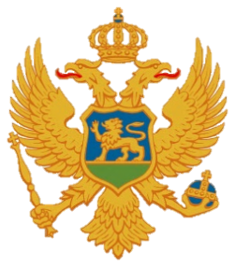

Statement of Montenegro
UPR 3rd cycle, Review of Gambia,
Geneva, 5 November 2019

Montenegro welcomes the distinguished delegation of Gambia and thanks for the presentation of its national report.
We welcome the engagement in the implementation of our recommendations given during second UPR review. We particularly welcome the moratorium on the death penalty and the ratification of the Second Optional Protocol to the ICCPR. We welcome that practices of child marriages and female genital mutilation have been criminalized and also that a gender unit had been established by the Attorney General’s Chambers to train law enforcement agents on the application of the relevant legislation concerning the sexual violence.
We encourage the further engagement in the process of transitional justice. We express our concern about the restrictive legislation relating to freedom of expression and also the absence of torture as a criminal offence in the Criminal Code.
Montenegro recommends the following:
1) to ratify the Optional Protocol to the CEDAW;
2) to adopt the Child Protection Strategy with appropriate action plans.

I thank you.

