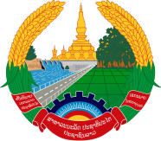

Statement by Mr. Sitsangkhom SISAKETH, Deputy Permanent Representative of the Lao PDR
At the 34th Session of UPR Working Group
Geneva, 4 - 15 November 2019

Review of Islamic Republic of Iran: 8 November 2019

Mr. President,
Laos welcomes the distinguished delegation of Iran to the UPR session and commends for its comprehensive report on human rights development in the country.

Laos warmly congratulates the Government of the Islamic Republic of Iran for a good progress in the promotion and protection of human rights in the country, especially the promotion of women’s cultural, social, economic, civil and political rights, and the rights of persons with disabilities, including children with disabilities.

In this connection, Laos wishes to recommend as follows:

- First, continues to implement its legislative programmes and measures to further promote the rights as well as the empowerment of women in all areas; and
- Second, continues its efforts in promoting right to education to ensure that all children, including children with disabilities can access to formal education.

We wish Iran all the best of its review.

I thank you, Mr. President.

