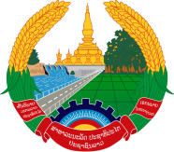

Statement by Representative of the Lao PDR
At the 34th Session of UPR Working Group
Geneva, 4 - 15 November 2019

Review of El Salvador: 4 November 2019

Mr. President,
The Lao PDR warmly welcomes the distinguished delegation of El Salvador to the 34th Session of the UPR and commends for its comprehensive report on human rights.

The Lao PDR wishes to congratulate the Government of El Salvador for the progress made of its efforts to promote and protect human rights in the country, especially the implementation of the national policies and programmes to eliminate discrimination against women and the establishment of the specialized court for a Life Free of Violence and Discrimination for Women in 2016.

In this connection, The Lao PDR would like to recommend as follows:

- First, continues its approach of the national support system to women affected by violence; and
- Second, continues its efforts to implement the national policies and programmes aimed at further promoting gender equality in both public and private sectors.

We wish El Salvador all the best of its UPR.

I thank you, Mr. President.

