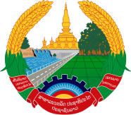

Statement by Representative of the Lao PDR
At the 34th Session of UPR Working Group
Geneva, 4 - 15 November 2019

Review of Egypt: 13 November 2019

Mr. President,
Laos welcomes the distinguished delegation of Egypt to the UPR session and commends for its comprehensive report on human rights development in the country.

Laos warmly congratulates the Government of the Egypt for a remarkable progress in the promotion and protection of human rights in the country, especially the enhancement on empowering women and children rights in the field of cultural, social, economic, civil and political rights.

In this connection, Laos wishes to recommend as follows:

- First, continues to implement its national strategy to empower Egyptian women 2030, in line with its constitution and the United Nations Sustainable Development Goals; and
- Second, continues to improve children’s quality of life through the development of health and education system to ensure that all children, including children with disabilities are able to access basic services.

We wish Egypt every success of its review.

I thank you, Mr. President.

