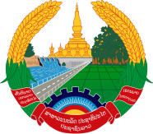

Statement by Representative of the Lao PDR
At the 34th Session of UPR Working Group
Geneva, 4 - 15 November 2019

Review of Angola: 7 November 2019

Mr. President,
Laos welcomes the distinguished delegation of Angola to the UPR session and thanks for its comprehensive report on human rights developments in the country.

Laos congratulates the Government of Angola for achievements made in the promotion and protection of human rights in the country, in particular the implementation of its “National Policy for Gender Equality and Equity”, and programme for sustainable development and poverty alleviation.

In the spirit of constructive dialogue, Laos wishes to make the following recommendations:

- First, continues its efforts to implement the National Policy for Gender Equality to further promoting equal opportunities for women and men in all areas; and
- Second, enhance its efforts in the implementation of the “Programme of Rural Development and the Fight against Poverty” to ensure sustainable development and poverty alleviation in the country.

We wish Angola every success for its review.

I thank you, Mr. President.

