Permanent Mission of Rwanda
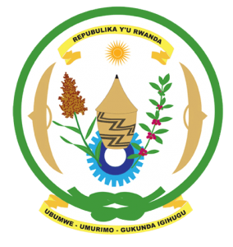
34th Session of the Universal Periodic Review Working Group
Review of Egypt
13th November 2019
Statement delivered by H.E. Marie Chantal Rwakazina

Thank you, Mr. President,
Rwanda warmly welcomes the delegation of Egypt and thanks them for the presentation of their national report and the update just provided.
Rwanda commends Egypt’s continued efforts to promote and protect human rights including through the enactment and implementation of laws and policies to improve the social and economic wellbeing of its citizens.
Rwanda recommends that Egypt:
- Strengthen measures to combat violence against women and domestic violence including through enhancing existing legislation to better ensure accountability for victims.
- Consider imposing a de facto moratorium on the use of the death penalty with a view to its total abolition
Rwanda wishes Egypt a very successful review outcome.
Thank you.

