Permanent Mission of Rwanda
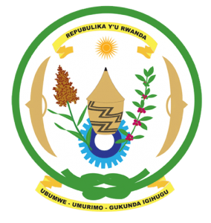
34th Session of the Universal Periodic Review Working Group

Review of Slovenia

12th November 2019

Statement delivered by Mr. Moses Rugema

Thank you, Madame Vice-President,
Rwanda warmly welcomes the delegation of Slovenia and thanks them for the presentation of their national report.
Rwanda commends Slovenia for the steps that it has taken to implement the recommendations of its last UPR including the adoption of legislation and implementation of policies aimed at the promotion and protection of human rights. We further applaud Slovenia’s firm commitment to women’s empowerment and gender equality at the national and international level.
While taking positive note of the update provided this morning, Rwanda recommends that Slovenia:
- Strengthen the legislative framework in cases of racist hate speech and racially motivated violence by ensuring effective investigation and appropriate prosecution and punishment of perpetrators.
- Strengthen measures aimed at preventing and combating violence against women, including domestic violence and sexual abuse by ensuring that victims have access to effective remedies and means of protection.
We wish Slovenia a successful review outcome. Thank you

